Date:22/07/2022
As per the collected feedback from all stakeholders during Even and Odd Semester 2021-22, Following are the highlighted points;
Action Taken Report on Feedback
General analysis of feedback regarding curriculum upgradation received from different stakeholders in an important measure for the quality enrichment of the institution. The institute has a multidimensional, well defined process of assessment including feedback by the stake holders like students, teaching faculty members, parents, Alumni and Employers to identify the curricular gaps and take measure to bridge it by supplementing the curriculum with add-on courses, guest lectures, workshops, seminars, industrial visit etc. The objective of this system is to provide a framework for acquiring, summarizing and documenting information.
Feedback Analysis and Action taken
Feedback | Action taken
Students  - Students feel that the soft-skills training would improve their chances of placement in industry.  - Internship must be Encouraged.  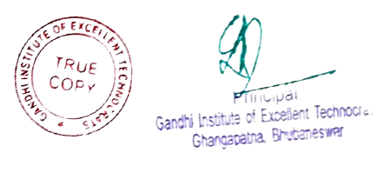  - Improvement needed in personality development and communication skill.  - Improvement needed in recent advancement of technology. | - All Departments have organized Workshops and Seminars for Students by inviting experts from industries and reputed institutions. 02 such Workshops/Seminars conducted in the year 2021-22, more such activities will be conducted in coming years.  - Students were sent for internship during summer and winter vacation. 1238 students undergone internship in the year 2021-22. We will increase the no. of students in the next year.  - The Institution conducted 2 certificate courses which includes Pre Placement Training for personality development and English communication for improvement of communication skill of the students.  - For the improvement of the technical knowledge on recent advancement , the institution has conducted 19 add-on courses for different disciplines.
Teacher:  - Industry oriented syllabus should be introduced.  - Extra guidance for the slow learner students in academic activities. | - Conducted Faculty Development Programmes by inviting eminent persons from different industries to focus on the industry based technical knowledge. More such programs will be organized in next year.  - Remedial classes conducted.
Parents:  - They were recommended for the updated journals in the library.  - Transportation should reach on remote area.  - They feel that the canteen facility should be improved. | - Online journals like E-Journals(DELNET), NPTEL, Shodhganga, e-shodhsindhu, access to National Digital Library of India is already available in the institute library.  - The usual bus routes are elongated to remote areas.  - Canteen facility has been improved. Outlet of Nescafe and vending machine is now available in the Institute.
Alumni:  - Financial support for participation in National Conferences at NIT and IITs. | - Institute already giving financial support for students participation in National Conferences at NIT and IITs.
Employer:  - Technical skill should be provided to students.  - Implement current technology in syllabus. | - Started Skill training certificate program for all the students.  - Current technology and trends in industry implemented by conducting skill training certificate program and beyond syllabus topics.
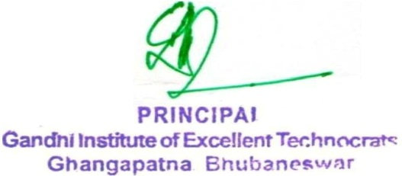

PRINCIPAL
Submitted to:
- IQAC
- Governing Body

